Project Design Phase-II
Data Flow Diagram & User Stories

Date | 04 October 2026
Team ID | SWTID-2026-5690
Project Name | Implement Client Script & UI Policy (Incident)
Maximum Marks | 4 Marks

Data Flow Diagrams:
A Data Flow Diagram (DFD) is a traditional visual representation of the information flows within a system. A neat and clear DFD can depict the right amount of the system requirement graphically. It shows how data enters and leaves the system, what changes the information, and where data is stored.
Level 0 DFD – Client Script & UI Policy on the Incident Form:
At Level 0, the Incident Form (with its Client Scripts and UI Policies) is shown as a single process. The Caller / End User and the Service Desk Agent enter incident details, the Administrator configures the scripts and policies, and validated records are stored in the Incident table.
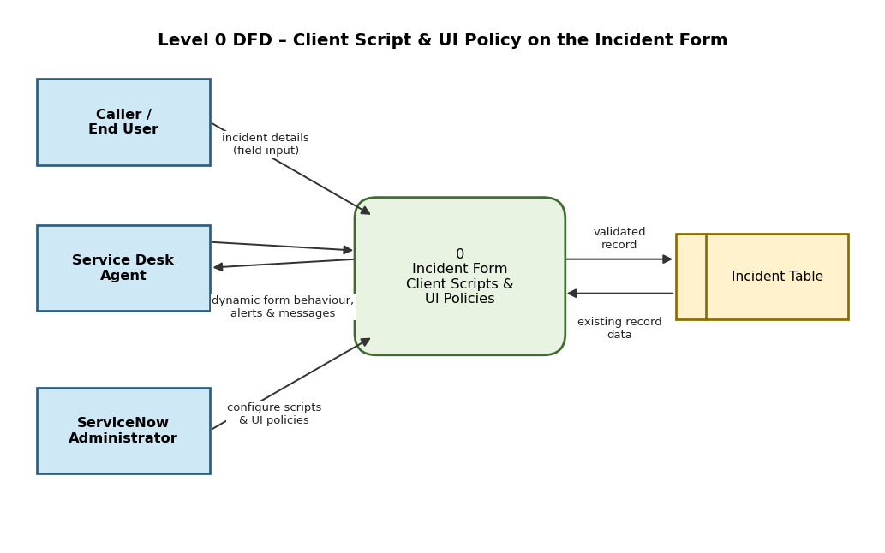
Level 1 DFD – Client Script & UI Policy Processing:
At Level 1, the process is broken down into form load (onLoad script), UI Policy evaluation, field-level validation (onChange script), submit-time validation (onSubmit script) and saving of the record. Data store D1 holds the Client Script and UI Policy configuration; D2 is the Incident table.
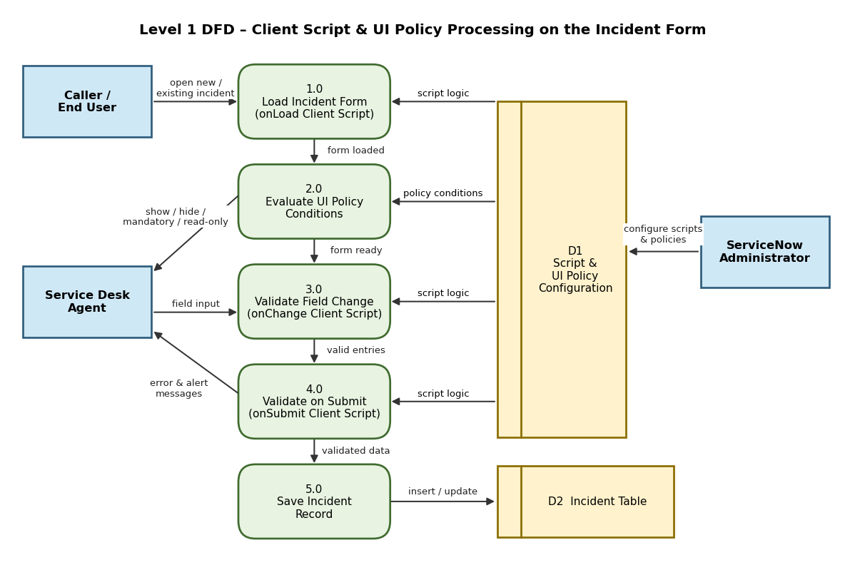

User Stories
Use the below template to list all the user stories for the product.
User Type | Functional Requirement (Epic) | User Story Number | User Story / Task | Acceptance criteria | Priority | Release
Caller / End User | Incident Form Validation (Client Script) | USN-1 | As a caller, I can submit an incident only after entering a Short description of at least 10 characters, so that my issue is clearly described. | An alert is shown and submission is blocked if the Short description is under 10 characters | High | Sprint-1
 |  | USN-2 | As a caller, I see an onLoad information message on a new Incident form that guides me to provide complete details. | The message appears only when a new incident form is loaded | Low | Sprint-2
 | Dynamic Field Behaviour (UI Policy) | USN-3 | As a caller, when I select a Category, I am offered only the relevant Subcategory options. | Subcategory is cleared and filtered whenever the Category is changed | Medium | Sprint-1
Service Desk Agent | Dynamic Field Behaviour (UI Policy) | USN-4 | As an agent, I want the On hold reason field to be visible and mandatory only when State is On Hold. | The field is hidden otherwise; the record cannot be saved On Hold without a reason | High | Sprint-1
 |  | USN-5 | As an agent, I want Resolution code and Close notes to become mandatory when State is Resolved or Closed. | The incident cannot be resolved or closed until both fields are filled | High | Sprint-1
 |  | USN-6 | As an agent, I want the Assigned to field to be read-only until an Assignment group is selected. | Assigned to becomes editable as soon as an Assignment group is chosen | Medium | Sprint-2
Incident Manager | Incident Form Validation (Client Script) | USN-7 | As an incident manager, I want Priority 1 incidents to be blocked on submit if no Assignment group is selected. | An error message is shown and the submission is stopped | Medium | Sprint-2
 |  | USN-8 | As an incident manager, I want an onChange alert when both Impact and Urgency are set to High so that the incident can be escalated. | An alert appears when Impact = 1 - High and Urgency = 1 - High | Medium | Sprint-2
Administrator | Configuration & Deployment | USN-9 | As an administrator, I can create onLoad, onChange and onSubmit Client Scripts on the Incident table. | Scripts are active, saved and run on the Incident form | High | Sprint-1
 |  | USN-10 | As an administrator, I can create UI Policies with conditions and UI Policy Actions on the Incident table. | Policies are active and the fields respond to the conditions | High | Sprint-1
 | Testing | USN-11 | As an administrator, I can test the behaviour by impersonating different users (caller, ITIL agent) and verify each scenario. | All test cases pass for each role without console errors | Medium | Sprint-2
 |  | USN-12 | As an administrator, I can capture all scripts and policies in an Update Set for migration to other instances. | The Update Set contains every Client Script and UI Policy created | Low | Sprint-2

